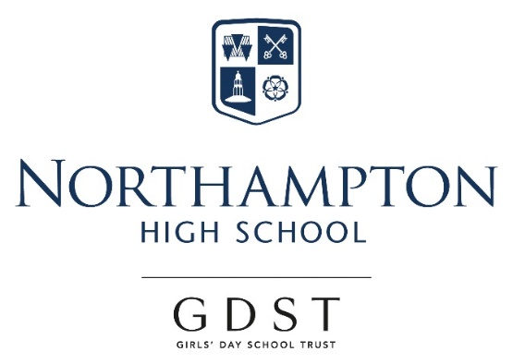

Appointment of

Teacher of Classics

For September 2018

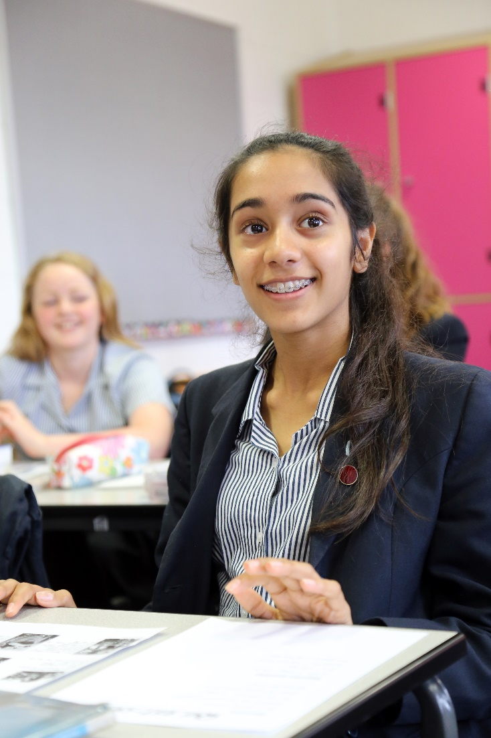
Northampton High School
“Thank you for your interest in our very special school, where we are as ambitious for ourselves as we are for our students. I am confident that you too would find it a stimulating and rewarding place to develop your practice and to move forward in your career.” Dr Helen Stringer, Headmistress.

Northampton High School is a leading independent girls’ day school and one of the oldest girls’ schools in the country, with a tradition of pioneering in girls’ education going back to its foundation in 1878. We are an all through school (ages 2-18) with over 600 girls across the nursery, junior and senior schools, including a sixth form of about 120 students. Our school is situated in Hardingstone, just outside the town of Northampton, in a leafy site with extensive playing fields and spacious buildings that were purpose built when the school moved from the town centre in 1992. The transport links are excellent, with easy access from the M1 and Northampton rail station a short taxi ride away. The school is a popular choice in the local vicinity and girls also join us from areas further afield, such as Milton Keynes, Warwickshire and Bedfordshire.

Northampton High is an academically selective school, although our intake is broad across the range of students considered to be above average nationally. Our girls are determined, sharp-witted, animated and curious. Public examination results are consistently excellent and students go on to study a wide range of subjects at prestigious universities, including Oxbridge, and a range of institutions for the Arts. We are confident that these outcomes come about because of our uncompromising emphasis on the highest quality in everything we do and our ethos of continual improvement for all, students and teachers alike. This is seen in our commitment to developing a 360 degree understanding of each girl, sustained by particularly warm and supportive pastoral care that weaves its way through all aspects of school life.

“I would say as a new teacher I had all the usual worries, where, how etc. but all the staff made me forget I was new. Everyone is very caring and the whole atmosphere in the school allows you to gently settle in and learn whilst having the best teaching experience.” Karla: joined in September 2017.

The GDST
GDST schools are experts in girls-only education and are members of a unique network which adds value to each school, student and member of staff. Networking opportunities with other teachers across the Trust enable staff to share best practice and develop initiatives that benefit all our schools and students. In addition to supporting the work of individual schools in supplying excellent induction and development opportunities for staff, the GDST network provides access to an extensive training programme. This includes opportunities including a middle leaders’ development course and a programme for those aspiring to senior leadership, as well as grants for individual courses of study.

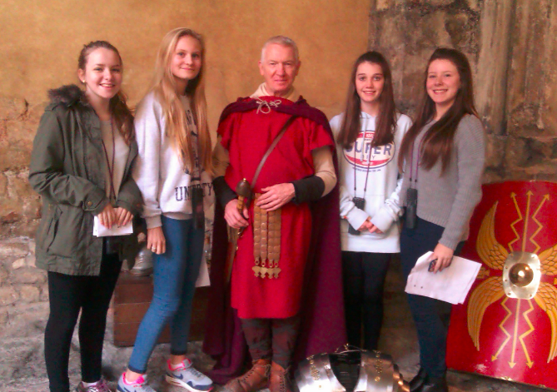
Teacher of Classics

The Post
Full-time, permanent post available from September 2018 (consideration of a substantial part-time arrangement may be possible).

The vacancy provides the opportunity for a well-qualified, inspirational teacher of Classics to work in the Classics subject area within the wider Languages Faculty and to teach Latin and Classical Civilisation across all age groups from Year 7 up to A Level (and Oxbridge entrance) and ideally Ancient Greek to GCSE. Also to contribute to extracurricular activities within Languages, working closely with colleagues in the Faculty and across the school.

The Person
We are looking for a well-qualified graduate with a passion for teaching and excellent subject knowledge of Latin and Classical Civilisation, ideally also of Ancient Greek. The successful candidate will have a strong understanding of the curriculum and a commitment to continuing professional development, as well as being efficient and organised. She/he will be a good communicator who can enthuse and inspire both pupils and colleagues and will have exciting ideas about the teaching Classics and the ways in which it can be further developed and encouraged across the whole school. The successful candidate will be able to help with the creation of engaging schemes of work, support with trips/visits, assist with university preparation and be committed to supporting the vibrant extracurricular life of the school.

The Faculty
Northampton High has a faculty system in the senior school, made up of Mathematics, English, Science, Languages, Humanities, Creative Arts and Sport. Classics is included within the Languages Faculty which also includes French, German and Spanish. Latin is taught to all pupils in KS3 and is then optional at GCSE and A Level. Our lessons are challenging and thought-provoking with a strong emphasis on creativity and collaboration. Within a supportive environment, we encourage all students to achieve their full potential and we aim to instil a genuine appreciation of classical civilisations and language learning.

Extracurricular provision
The Classics department have an annual programme of extracurricular trips: we take Upper 4/Year 9 pupils to the Roman museum in Bath. Lower 5/Year 10 pupils enjoy a study day at the Classics Faculty of Oxford University & Lower Sixth/ Year 12 pupils attend the Sixth Form set text study days for A Level Latin and Classical Civilisation at Cambridge University. The highlight of our programme is the residential trip to either Rome or Pompeii for pupils in Lower 5/ Year10-Upper Sixth. Our next oversees trip is to Rome is in February 2019.
Pupils are encouraged to attend lunchtime sessions given by visiting speakers which in the past have included alumnae and children’s author, Caroline Lawrence.

The Curriculum
Years 7-9 (Upper Third, Lower Fourth, Upper Fourth)
Cambridge Latin Course Books I, II and III

Years 10 and 11 (Lower Fifth and Upper Fifth)
Cambridge Latin Course Books IV and V supplemented by Essential Latin for GCSE.

A Level (6-1 and 6-2)
For Classical Civilisation we teach the following components:
The World of the Hero, Greek Theatre and Love and relationship.
Set texts currently being studied for Latin are:
Cicero de Milone, and Seneca’s Letters and Virgil Books VIII and X.

Facilities and Equipment
The Languages Faculty is well-equipped, featuring ipads, Clever Touch boards in all classrooms and we subscribe to the Cambridge Latin Course eLearning resource for Books I and II.

Terms and conditions of the post
The GDST offers attractive salaries and pay progression, when compared with the education sector generally, and has its own pay and grading structure, and system of career progression. Leadership and teaching excellence are recognised and rewarded in our schools – please see the link below to download salary details.

https://www.gdst.net/careers/rewards-and-benefits

Benefits include:
- Membership of Teaching Staff Pension Scheme
- Access to the GDST central training and development programme
- Up to 50% discount on fees for children at GDST schools
- Training grants for obtaining further qualifications
- Computer Loans: Interest free loans are available to staff to enable them to buy a computer for personal use at home or school
- Cycle Scheme: the school is part of the scheme which enables staff to purchase bicycles and equipment at a tax advantageous rate and pay for the equipment over 12 months
- Lunches: free lunches are provided to all staff during term time
- Four weeks’ study leave for teachers after ten years’ continuous service
- Accredited NQT induction

Application and Interview Process
Applications should be submitted by midday, on Friday 22 June 2018 at the latest; however, applications may be considered in advance of the deadline.
Candidates should complete the application form provided with comprehensive details of qualifications and experience (including any periods of time out of employment, giving reasons for these) and the names, addresses, telephone numbers and email addresses of two professional referees, one of whom should be the Head of their present or most recent school. Candidates should also include a covering letter outlining their motivation for applying for the post. Applications which are not completed on the application form provided will not be considered.
Completed applications should be emailed to admin@nhs.gdst.net or sent to:

Mrs Dee Brown, PA to the Headmistress
Northampton High School
Newport Pagnell Road
Northampton
NN4 6UU

Shortlisted candidates will be invited for interview in the fortnight beginning 25 June 2018. As part of this process, they will be expected to teach a lesson of up to 35 minutes, for which a full prior briefing will be given.
All adults employed at the school are cleared for working with children and young people through the Disclosure & Barring Service. Please see attached information regarding the Girls’ Day School Trust guidelines on the Safeguarding of Children.

Further information about the school and the application form can be found on our website at: www.nhs.gdst.net

