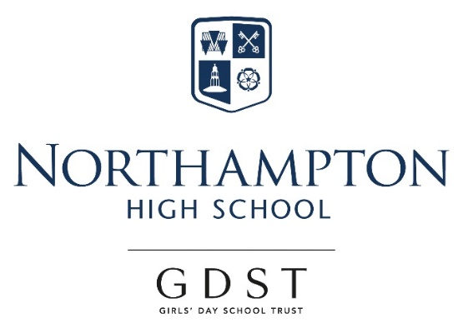

Appointment of

Teacher of Chemistry

Maternity cover September 2018 - July 2019

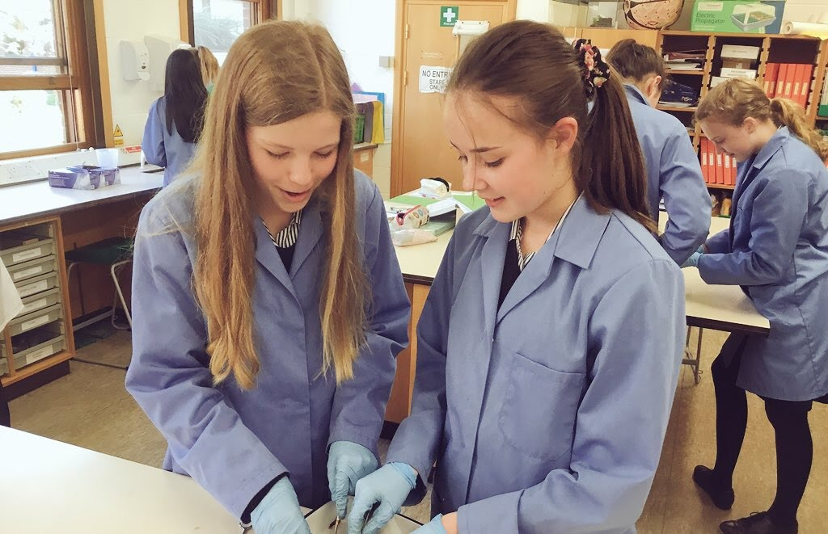
Northampton High School
“Thank you for your interest in our very special school, where we are as ambitious for ourselves as we are for our students. I am confident that you too would find it a stimulating and rewarding place to develop your practice and to move forward in your career.” Dr Helen Stringer, Headmistress.

Northampton High School is a leading independent girls’ day school and one of the oldest girls’ schools in the country, with a tradition of pioneering in girls’ education going back to its foundation in 1878. We are an all through school (ages 2-18) with over 600 girls across the nursery, junior and senior schools, including a sixth form of about 120 students. Our school is situated in Hardingstone, just outside the town of Northampton, in a leafy site with extensive playing fields and spacious buildings that were purpose built when the school moved from the town centre in 1992. The transport links are excellent, with easy access from the M1 and Northampton rail station a short taxi ride away. The school is a popular choice in the local vicinity and girls also join us from areas further afield, such as Milton Keynes, Warwickshire and Bedfordshire.

Northampton High is an academically selective school, although our intake is broad across the range of students considered to be above average nationally. Our girls are determined, sharp-witted, animated and curious. Public examination results are consistently excellent and students go on to study a wide range of subjects at prestigious universities, including Oxbridge, and a range of institutions for the Arts. We are confident that these outcomes come about because of our uncompromising emphasis on the highest quality in everything we do and our ethos of continual improvement for all, students and teachers alike. This is seen in our commitment to developing a 360 degree understanding of each girl, sustained by particularly warm and supportive pastoral care that weaves its way through all aspects of school life.

“Northampton High School is a wonderful place to work. It runs seemingly effortlessly, whilst exuding rigour and the highest of standards. This is due to the professionalism and capability of the staff. It is truly a cut-above.” Paul: joined in January 2017.

The GDST
GDST schools are experts in girls-only education and are members of a unique network which adds value to each school, student and member of staff. Networking opportunities with other teachers across the Trust enable staff to share best practice and develop initiatives that benefit all our schools and students. In addition to supporting the work of individual schools in supplying excellent induction and development opportunities for staff, the GDST network provides access to an extensive training programme. This includes opportunities including a middle leaders’ development course and a programme for those aspiring to senior leadership, as well as grants for individual courses of study.

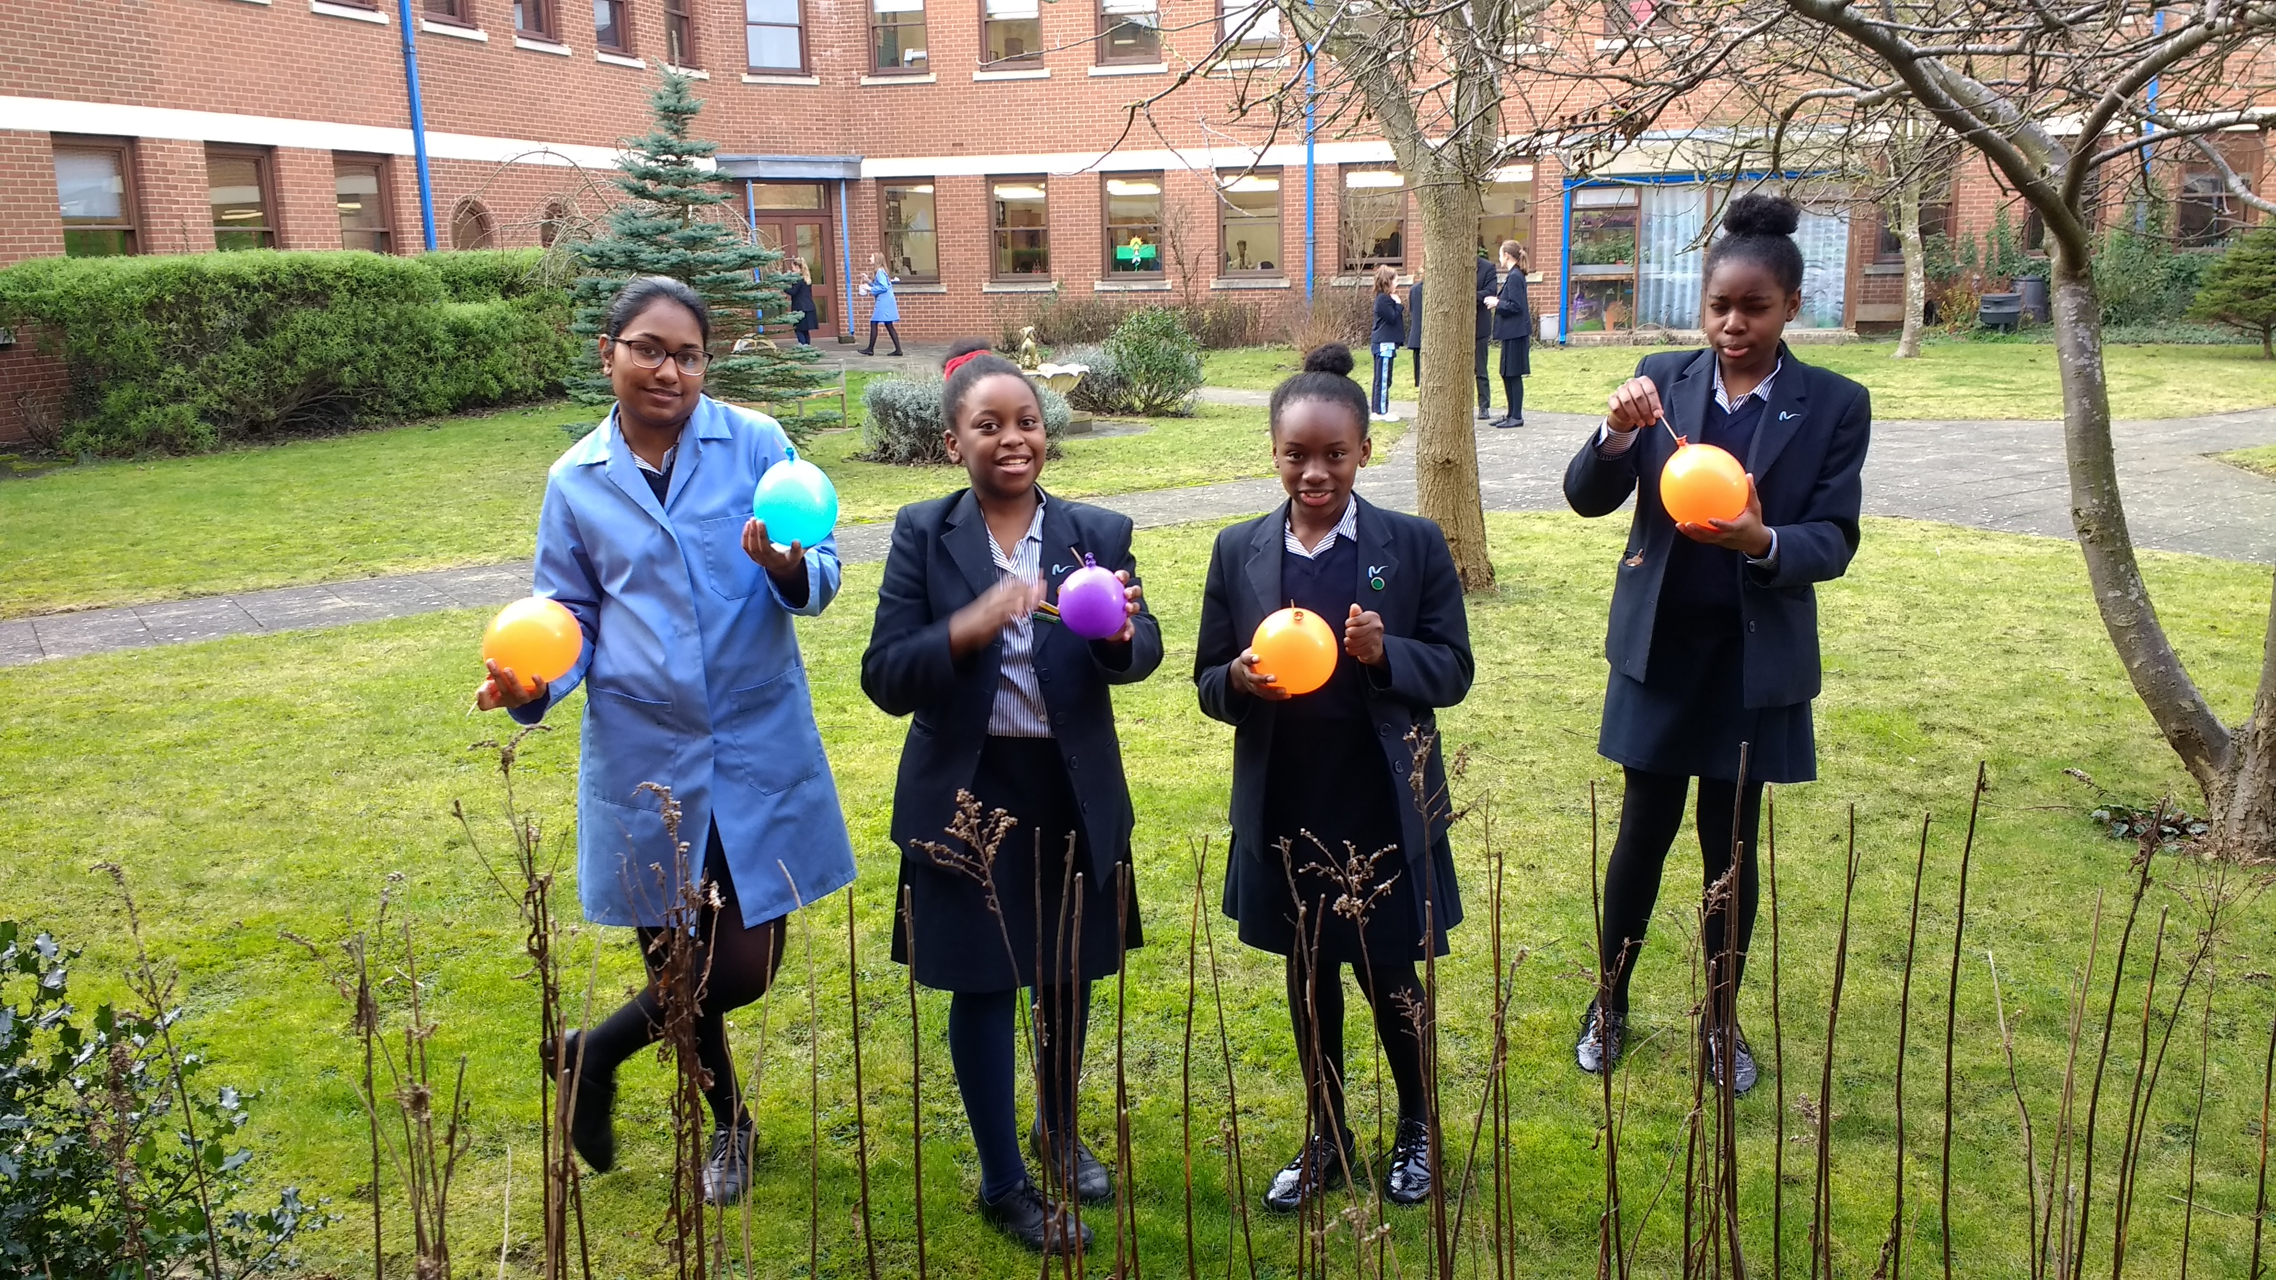
Teacher of Chemistry

The Post
Full-time teaching post, temporary (maternity cover), from September 2018 - July 2019.

The vacancy provides the opportunity for a well-qualified, inspirational teacher of Chemistry to teach across the Senior School from Year 7 up to A Level (and possibly Oxbridge entrance). Also to contribute to extracurricular activities within Chemistry, working closely with teachers and technical staff with the wider Science Faculty.

Person Specification
We are looking for a well-qualified graduate Chemist with a passion for teaching and excellent subject knowledge. The successful candidate will have a strong understanding of the curriculum and a commitment to continuing professional development, as well as being efficient and organised. She/he will be a good communicator who can enthuse and inspire both pupils and colleagues and will have exciting ideas about the teaching Chemistry and the ways in which it can be further developed and encouraged across the whole school, including in the junior school. The successful candidate will be able to create engaging schemes of work, lead trips/visits, support university preparation and be committed to supporting the vibrant extracurricular life of the school.

The Faculty
Northampton High has a faculty system in the senior school, made up of Mathematics, English, Science, Languages, Humanities, Creative Arts and Sport. Chemistry is included within the Science Faculty which comprises Biology, Chemistry, Physics and Psychology. Our lessons are challenging and thought-provoking with a strong emphasis on creativity and collaboration. Within a supportive environment, we encourage all students to achieve their full potential and we aim to instil a genuine love of Science.

Extracurricular provision
Chemistry infuses the life of the school. We encourage and nurture our young chemists from the very beginning. The school boasts a wide range of extracurricular clubs and groups including a collaboration with the Junior School in a Year 6/7 Science Club. Our Year 10 run their own Café Sci weekly and have wonderful speakers such as Dr Suzie Imber and many more. In KS4 we run a Chemistry clinic so students are given opportunities to come and extend their knowledge of current topics and in KS5 clinics focus on exam technique and practice. In terms of trips, we go to Scott Bader, Salters festival and many others. We compete in national competitions such as the RSC Olympiad nationally, and Top of the Bench locally. We also run a showpiece Chemistry lecture at Christmas encouraging Sixth Form to take part in the presentation.

The Chemistry Curriculum

Years 7-8 (Upper Third, Lower Fourth)
Year 7 and 8 follow a combined science curriculum and we currently use Activate Chemistry series of lessons which we have adapted to suit our students.

Years 9-11 (Upper Fourth, Lower Fifth and Upper Fifth)
From year 9 onwards the students follow their separate GCSE courses and we studt AQA GCSE both trilogy and Triple Science courses.

A Level (6-1 and 6-2)
At A level the students currently follow the AQA syllabus but will be changing to OCR in 2019.

Facilities and Equipment
There are 8 fully fitted and very well equipped labs within the Science Faculty and Chemistry share the upper floor with Psychology. We have three bespoke fitted fume cupboards and each lab has a new Clevertouch screen and integrated desktop. Support is offered by three dedicated and professional laboratory technicians.

Terms and conditions of the post
The GDST offers attractive salaries and pay progression, when compared with the education sector generally, and has its own pay and grading structure, and system of career progression. Leadership and teaching excellence are recognised and rewarded in our schools – please see the link below to download salary details.

https://www.gdst.net/careers/rewards-and-benefits

Benefits include:
- Membership of Teaching Staff Pension Scheme
- Access to the GDST central training and development programme
- Up to 50% discount on fees for children at GDST schools
- Training grants for obtaining further qualifications
- Computer Loans: Interest free loans are available to staff to enable them to buy a computer for personal use at home or school
- Cycle Scheme: the school is part of the scheme which enables staff to purchase bicycles and equipment at a tax advantageous rate and pay for the equipment over 12 months
- Lunches: free lunches are provided to all staff during term time
- Four weeks’ study leave for teachers after ten years’ continuous service
- Accredited NQT induction

Application and Interview Process
Applications should be submitted by midday, on Friday 11 May 2018 at the latest; however, applications may be considered in advance of the deadline.
Candidates should complete the application form provided with comprehensive details of qualifications and experience (including any periods of time out of employment, giving reasons for these) and the names, addresses, telephone numbers and email addresses of two professional referees, one of whom should be the Head of their present or most recent school. Candidates should also include a covering letter outlining their motivation for applying for the post. Applications which are not completed on the application form provided will not be considered.
Completed applications should be emailed to admin@nhs.gdst.net or sent to:

Mrs Dee Brown, PA to the Headmistress
Northampton High School
Newport Pagnell Road
Northampton
NN4 6UU

Shortlisted candidates will be invited for interview in the fortnight beginning 14 May 2018. As part of this process, they will be expected to teach a lesson of up to 35 minutes for which a full prior briefing will be given.
All adults employed at the school are cleared for working with children and young people through the Disclosure & Barring Service. Please see attached information regarding the Girls’ Day School Trust guidelines on the Safeguarding of Children.

Further information about the school and the application form can be found on our website at: www.nhs.gdst.net

