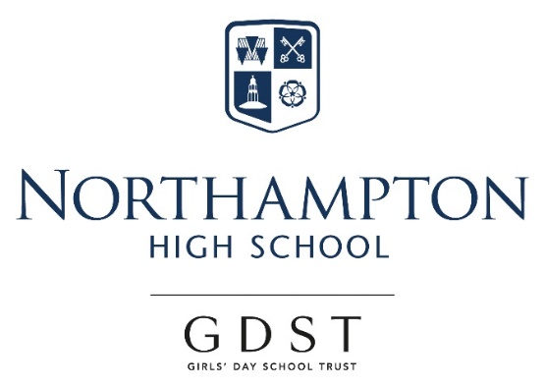

Appointment of

Science Technician (Biology specialism)

For September 2018

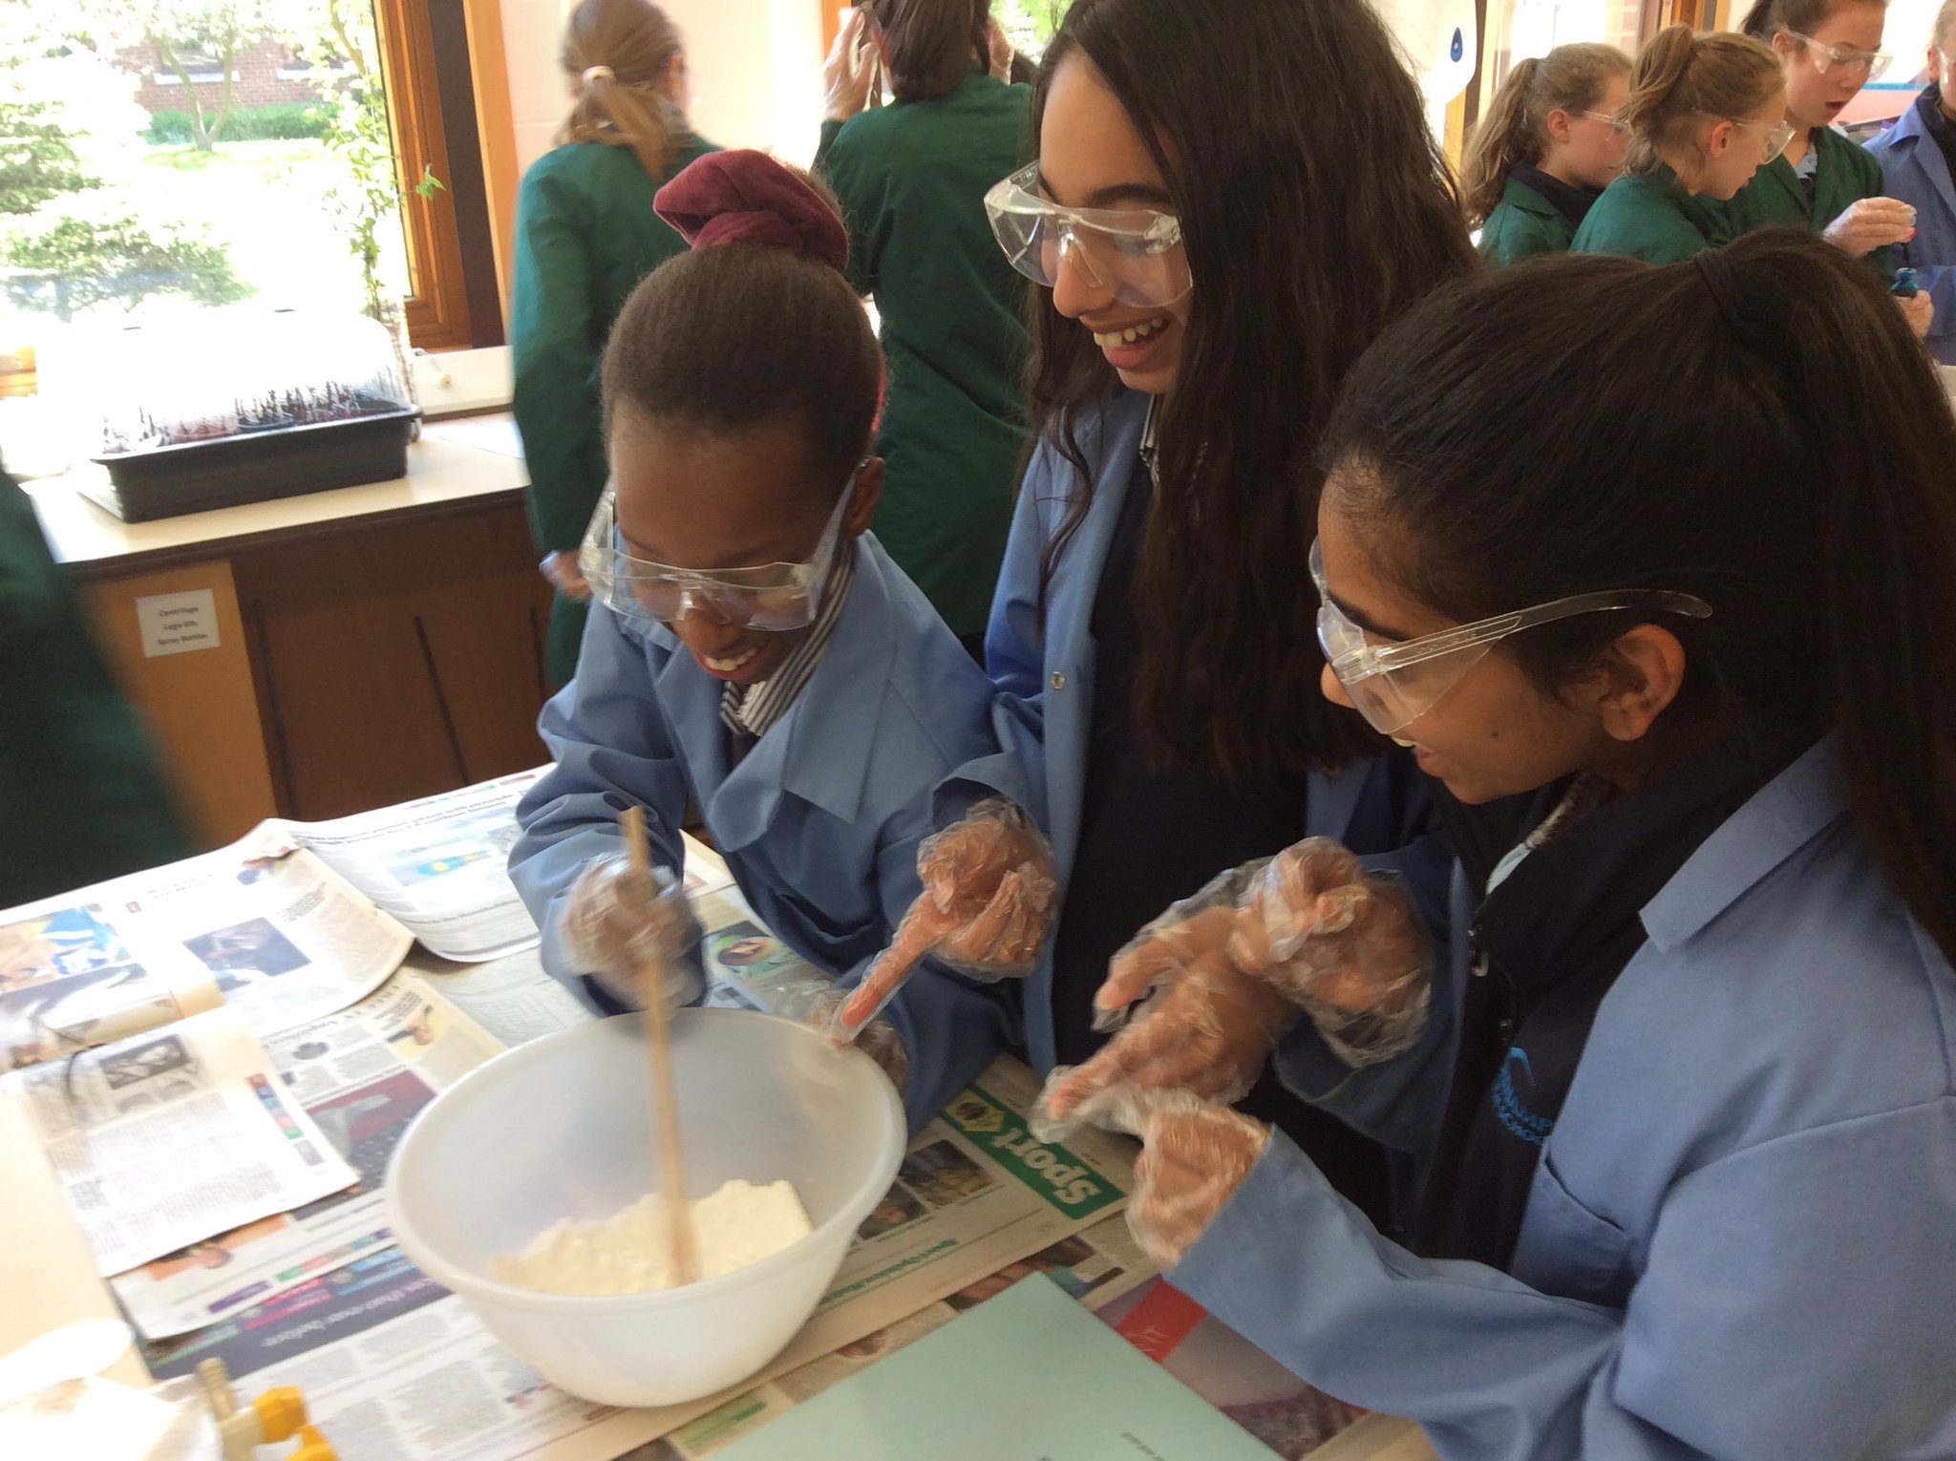
Northampton High School
“Thank you for your interest in our very special school, where we are as ambitious for ourselves as we are for our students. I am confident that you too would find it a stimulating and rewarding place to develop your practice and to move forward in your career.” Dr Helen Stringer, Headmistress.

Northampton High School is a leading independent girls’ day school and one of the oldest girls’ schools in the country, with a tradition of pioneering in girls’ education going back to its foundation in 1878. We are an all through school (ages 2-18) with over 600 girls across the nursery, junior and senior schools, including a sixth form of about 120 students. Our school is situated in Hardingstone, just outside the town of Northampton, in a leafy site with extensive playing fields and spacious buildings that were purpose built when the school moved from the town centre in 1992. The transport links are excellent, with easy access from the M1 and Northampton rail station a short taxi ride away. The school is a popular choice in the local vicinity and girls also join us from areas further afield, such as Milton Keynes, Warwickshire and Bedfordshire.

Northampton High is an academically selective school, although our intake is broad across the range of students considered to be above average nationally. Our girls are determined, sharp-witted, animated and curious. Public examination results are consistently excellent and students go on to study a wide range of subjects at prestigious universities, including Oxbridge, and a range of institutions for the Arts. We are confident that these outcomes come about because of our uncompromising emphasis on the highest quality in everything we do and our ethos of continual improvement for all, students and teachers alike. This is seen in our commitment to developing a 360 degree understanding of each girl, sustained by particularly warm and supportive pastoral care that weaves its way through all aspects of school life.

“Northampton High School is a wonderful place to work. It runs seemingly effortlessly, whilst exuding rigour and the highest of standards. This is due to the professionalism and capability of the staff. It is truly a cut-above.” Paul: joined in January 2017.

The GDST
GDST schools are experts in girls-only education and are members of a unique network which adds value to each school, student and member of staff. Networking opportunities with other staff across the Trust enable staff to share best practice and develop initiatives that benefit all our schools and students. In addition to supporting the work of individual schools in supplying excellent induction and development opportunities for staff, the GDST network provides access to an extensive training programme.

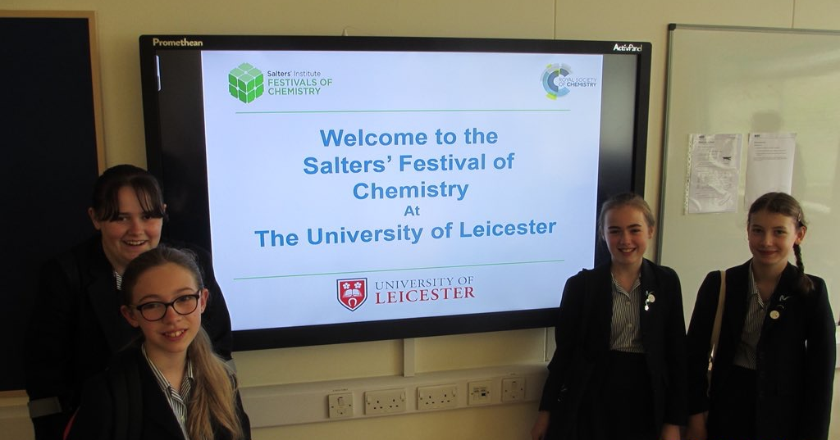
Science Technician (Biology specialism)

The Post
Full-time, permanent post available from September 2018 (consideration of a substantial part-time arrangement may be possible).

Northampton High School has an excellent Science Faculty with large numbers of students studying A Level Sciences in well-equipped laboratories. We seek to appoint a laboratory technician who has the knowledge and skills to provide technical support for Biology, up to A Level standard. The role involves taking responsibility for the practical resources for GCSE and A Level Biology lessons as well as contributing to the preparation of resources for KS3 Science. The ability to work closely with the other Science Technicians is vital as is a good general ability to support the other science subjects.

The Person
The successful candidate will need to be an enthusiastic individual with a passion for the Sciences and have excellent communication skills. Previous experience of working in a similar role support is desirable but not essential. A flexible approach with plenty of opportunity for initiative and problem-solving ideas to improve what we do still further is encouraged. This is a wonderful opportunity to join a school in which there is a strong team spirit and where students have a genuine desire to learn. There is opportunity to develop your skills through our CPD programme.

The Faculty
Northampton High has a faculty system in the senior school, made up of Mathematics, English, Science, Languages, Humanities, Creative Arts and Sport. Science lessons are challenging and thought-provoking with a strong emphasis on creativity and collaboration. Within a supportive environment, we encourage all students to achieve their full potential and we aim to instil a genuine appreciation of scientific processes and the role of STEM in the wider curriculum.

Extracurricular provision
The Science Faculty runs a wide range of extracurricular activities, including internal events and clubs, outreach work to local schools and organisations, and a large number of residential and day trips and visits. The technicians are integral to the success of this programme and may be asked to organise and take part in trips, as well as help run and set up activities.

Facilities and Equipment
There are 8 fully fitted and very well equipped labs within the Science Faculty and Biology share the lower floor with Physics, however, there are general labs on the first floor. We have three bespoke fitted fume cupboards and each lab has a new Clevertouch screen and integrated desktop.
Terms and conditions of the post
The GDST offers attractive salaries and pay progression, when compared with the education sector generally, and has its own pay and grading structure, and system of career progression. Leadership and teaching excellence are recognised and rewarded in our schools – please see the link below to download salary details.

https://www.gdst.net/careers/rewards-and-benefits

Benefits include:
- Access to the GDST central training and development programme
- Up to 50% discount on fees for children at GDST schools
- Training grants for obtaining further qualifications
- Computer Loans: Interest free loans are available to staff to enable them to buy a computer for personal use at home or school
- Cycle Scheme: the school is part of the scheme which enables staff to purchase bicycles and equipment at a tax advantageous rate and pay for the equipment over 12 months
- Lunches: free lunches are provided to all staff during term time

Application and Interview Process
Applications should be submitted by midday, on Friday 6 July 2018 at the latest; however, applications may be considered in advance of the deadline.
Candidates should complete the application form provided with comprehensive details of qualifications and experience (including any periods of time out of employment, giving reasons for these) and the names, addresses, telephone numbers and email addresses of two professional referees, one of whom should be the Head of their present or most recent school. Candidates should also include a covering letter outlining their motivation for applying for the post. Applications which are not completed on the application form provided will not be considered.
Completed applications should be emailed to a.gates@nhs.gdst.net or sent to:

Mrs Anna Gates, HR Officer
Northampton High School
Newport Pagnell Road
Northampton
NN4 6UU

We aim to invite shortlisted candidates for interview in the week beginning 9 July 2018. As part of this process there will be a technical task, for which a full prior briefing will be given.
All adults employed at the school are cleared for working with children and young people through the Disclosure & Barring Service. Please see attached information regarding the Girls’ Day School Trust guidelines on the Safeguarding of Children.

Further information about the school and the application form can be found on our website at: www.nhs.gdst.net

